题目：如何使用MySQL EntityFramework 组件处理MYSQL PaaS DB
MySQL Database on Azure 是Azure 平台上推出的 MySQL 云数据库服务，通过全面兼容 MySQL 协议，为用户提供了一个全托管的性能稳定、可快速部署、高可用、高安全性的数据库服务。客户可以使用常见的支持MySQL的平台与技术进行开发与集成。本文演示了如何使用MySQL EntityFramework 组件对MySQL PaaS DB进行操作。

系统环境/应用程序信息：
ASP.NET 2005 Core \ MYSQL EntityFrameWork Core
在一个VS 2015 net core的环境中，安装entity frame work core 组件，代码和测试后结果如下：

其中Data1Context.cs 文件为：

using Microsoft.EntityFrameworkCore;
using MySQL.Data.EntityFrameworkCore.Extensions;

namespace ConsoleApp1
{
/// <summary>
/// The entity framework context with a data1 DbSet
/// </summary>
public class Data1Context : DbContext
{
public Data1Context(DbContextOptions<Data1Context> options)
: base(options)
{ }

public DbSet<Data1> Data1 { get; set; }
}

/// <summary>
/// Factory class for EmployeesContext
/// </summary>
public static class Data1ContextFactory
{
public static Data1Context Create(string connectionString)
{
var optionsBuilder = new DbContextOptionsBuilder<Data1Context>();
optionsBuilder.UseMySQL(connectionString);

//Ensure database creation
var context = new Data1Context(optionsBuilder.Options);
context.Database.EnsureCreated();

return context;
}
}

/// <summary>
/// A basic class for an Employee
/// </summary>
public class Data1
{
public int Id { get; set; }
public string Name1 { get; set; }
}

}
Program.cs 文件为：
using System;
using System.Collections.Generic;
using System.Linq;
using System.Threading.Tasks;
using Microsoft.Extensions.Configuration;

namespace ConsoleApp1
{
public class Program
{
public static void Main(string[] args)
{
var builder = new ConfigurationBuilder().AddJsonFile("appsettings.json", optional: false, reloadOnChange: true);

var configuration = builder.Build();

string connectionString = configuration.GetConnectionString("SampleConnection");

// Create an employee instance and save the entity to the database
var entry = new Data1() { Id = 3, Name1 = "XingBing" };

using (var context = Data1ContextFactory.Create(connectionString))
{
context.Add(entry);
context.SaveChanges();
}

Console.WriteLine($"Data1 was saved in the database with id: {entry.Id}");
Console.ReadKey();
}
}
}

appsettings.json：
{
"ConnectionStrings": {
"SampleConnection": "server=XXXXXX.mysqldb.chinacloudapi.cn;userid=XXXXXX%YYYYYY;pwd=XXXXXXXXX;port=3306;database=xyudb;sslmode=none;"
}
}

project.json :
{
"version": "1.0.0-*",
"buildOptions": {
"debugType": "portable",
"emitEntryPoint": true,
"copyToOutput": {
"include": "appsettings.json"
}
},
"dependencies": {
"Microsoft.Extensions.Configuration": "1.0.0",
"Microsoft.Extensions.Configuration.Json": "1.0.0",
"Microsoft.EntityFrameworkCore": "1.0.0",
"MySql.Data.Core": "7.0.4-IR-191",
"MySql.Data.EntityFrameworkCore": "7.0.4-IR-191"
},
"frameworks": {
"netcoreapp1.0": {
"dependencies": {
"Microsoft.NETCore.App": {
"type": "platform",
"version": "1.0.0"
}
},
"imports": [
"dnxcore50",
"portable-net452+win81"
]
}
}
}

项目组成：

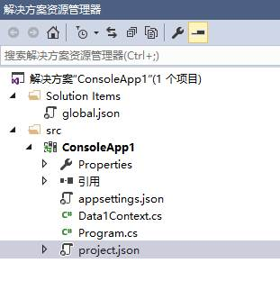
运行及测试结果：

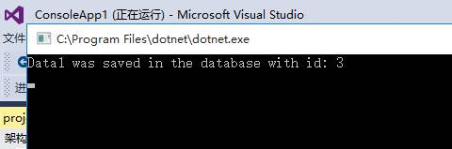

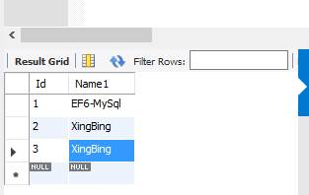

组件地址：https://www.nuget.org/packages/MySql.Data.EntityFrameworkCore
参考方法：http://insidemysql.com/howto-starting-with-mysql-ef-core-provider-and-connectornet-7-0-4/

